**INTRODUCTION**

A **maze** is a path or collection of paths, typically from an entrance to a goal. The word is used to refer both to branching tour puzzle through which the solver must find a route, and to simpler non-branching (‘unicursal’) patterns that lead unambiguously through a convoluted layout to a goal. The pathways and walls in a maze are typically fixed, but puzzles in which the walls and paths can change during the game are also categorized as mazes or tour puzzles.

## What is a maze?

It's a place with high walls or hedges, where you wander around and get lost. It's a little more complicated than that. Humanity has always enjoyed patterns. Some of the earliest patterns were spirals, either simple ones or double ones where you wound your way into the centre and out again. I think of these as [**pre-maze patterns**](https://www.theedkins.co.uk/jo/maze/simple/index.htm)**.** Later the [**Cretan (or classical) pattern**](https://www.theedkins.co.uk/jo/maze/cretan/index.htm) arrived. Everyone agrees that this is a maze, but it has no choices. There is one path winding its way to the center, without branches. It's really just a complication of a spiral.

Maze and Labyrinth are two words which have been used interchangeably for this type of design throughout English history. The word Labyrinth probably comes from the word Labrys, a double headed axe. This was a religious symbol of ancient Crete.

**OBJECTIVE**

Their goal is **to find the secret path and get everyone from the start point to end**. Students take turn according to their number and they each get a chance to guess where the path is. Mazes have essentially possible objective  **to escape, to get the prize, to trace a path, to be a metaphor, to be a stage**. Mazes are essentially the puzzles that we initially have on paper which we often see children solving from a small age. They are created and made available to children in various patterns, drawings and designs to attract them so that they get hooked onto them. It is interesting to note that practicing mazes not only benefit children but these also aid therapists to address and highlight a variety of abilities amongst children.  Let’s look at some of those aspects below :

**Enhance Cognitive Skills :** Mazes improve the cognitive skills of children. They work like brain boosting exercises. While solving them, it makes them think, reason and remember.

## **Fine Tune Motor Skills :**

## Mazes require the children to navigate the right path through the narrow passages without hitting their pencils or markers to the black lines which are the borders of the maze passages.

## **Strengthen Visual Skills**

Before they begin to solve the maze, children do plan out their moves. Whether they realize it or not but they organically scan their eyes over the Maze circuit to decide how to solve it.

**FEASIBILITY STUDY**

A feasibility study is a high-level capsule version of the entire System analysis and Design Process. The study begins by classifying the problem definition. Feasibility is to determine if it's worth doing. Once an acceptance problem definition has been generated, the analyst develops a logical model of the system. A search for alternatives is analyzed carefully. There are 3 parts in feasibility study.

* **Operational Feasibility** :

Question that going to be asked are:

* **Will the system be used if it developed and implemented?**
* **If there was sufficient support for the project from the management and from the users.**
* **Have the users been involved in planning and development of the Project**
* **Will the system produce poorer result any respect or area?**

This system can be implemented in the organization because there is adequate support from management and users. Being developed in Javascript ,CSS so that the necessary operations are carried out automatically.

* **Technical Feasibility:**
* **Does the necessary technology exist to do what is been suggested?**
* **Does the proposed equipment have the technical capacity for using the new system?**
* **Are there technical guarantees of accuracy, reliability and data security?**
* **The project is developed on Pentium version processor with 256-1034 MB RAM**
* **The environment required in the development of system is any windows platform The observer pattern along with factory pattern will update the results eventually.**

**Financial and Economic Feasibility:**

The system developed and installed will be good benefit to the organization. The system will be developed and operated in the existing hardware and software infrastructure. So, there is no need of additional hardware and software for the system.

**METHODOLOGY**

The game in which there is a start point where person has to start from a point and have to find the way to solve it and have to take the pickle/coin etc to the end point.

As a group, their goal is to find the secret path and get everyone from the start point to end. People take turns according to their number and they each get a chance to guess where the path is.

When it is their turn, they will step into the maze at the start and begin to choose an path– either forward, to the side or diagonal to the one they are standing on. Players continue their turn if they are right.

Once they step into an incorrect path, it is the next person’s turn. As they begin to discover the path, they can mark it with markers to help the rest of the group. Once they have uncovered the secret path each person needs to go through from start to end, while everyone continues to remain silent.

**DATA FLOW DIAGRAM**

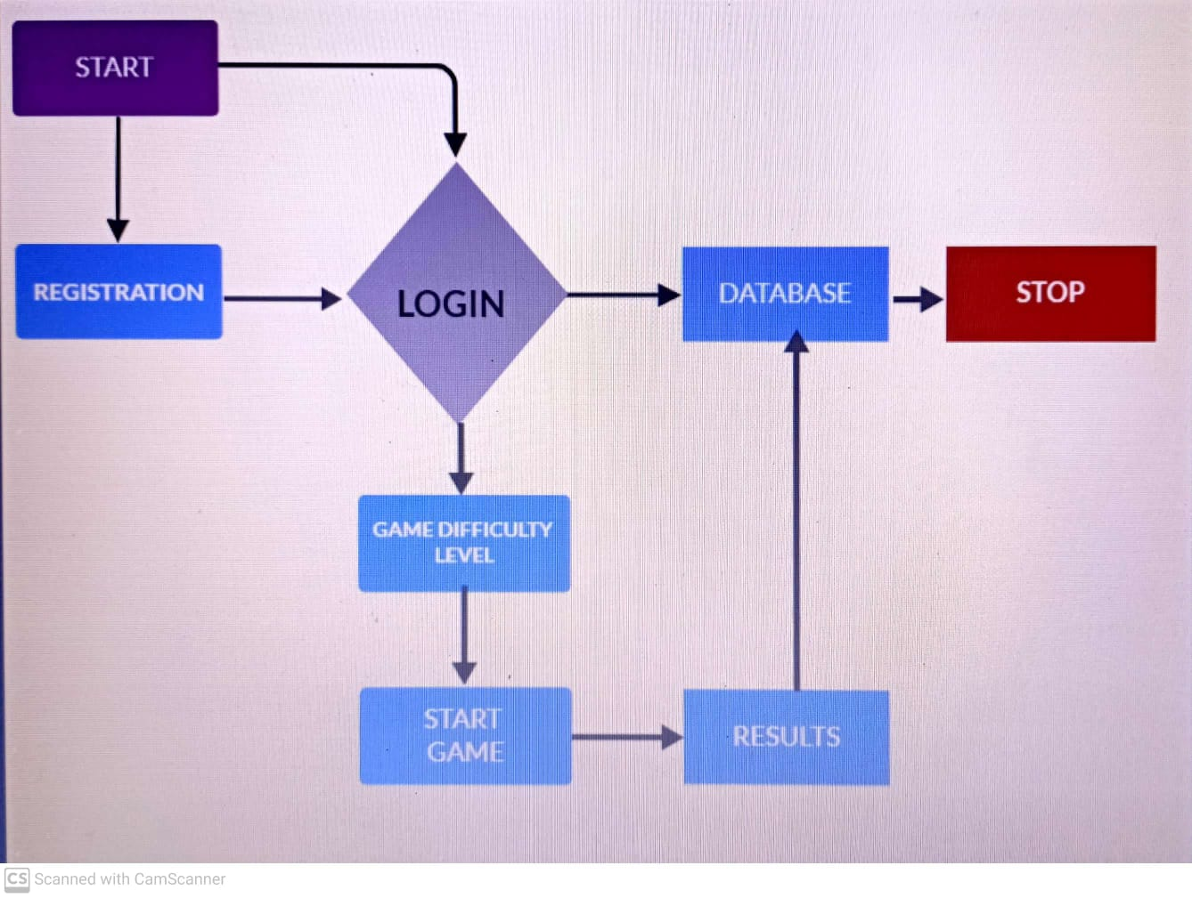

**MODULE SPECIFICATIONS**

**The Proposed system are divided into 4 types:**

* **Registration**
* **Login**
* **Game Difficulty Levels**
* **Results**

**REGISTRATION:**

A user have to make account on our server before playing game. They have to register first their full name after that they have to create a username ,so that he/she can do login to their account . After creating username they have to write their e-mail address and have to create a strong password.

**LOGIN** :

On coming login page , user have to know their email-id and password that they have created while doing registration. If they can’t recognize the email-id or password, they have to register again on our server to play the game. After filling credentials user have to click on login button to enter our server and play game.

**Game Difficulty Levels** :

After login, user is on the interface where game is about to start. There is 5*5 or 6*6, 7*7, 8*8 cube shape maze game , where user can select their game difficulty level according their wish/mind. There are 4 types of levels in this game : Easy , Medium , High , Moderate/Hard.

**RESULTS**:

After finishing the game , it shows result that in how much steps user is able to find the correct path i.e, in how many steps user take the coin/insect to the end point successfully.

**SOFTWARE AND TECHOLOGIES USED**

1. **VISUAL STUDIO CODE:**

Visual Studio Code, also commonly referred to as VS Code, is a source-code editor made by Microsoft for Windows, Linux and macOS. Features include support for debugging, syntax highlighting, intelligent code completion, snippets, code refactoring, and embedded Git. Users can change the [theme](https://en.wikipedia.org/wiki/Theme_(computing)), [keyboard shortcuts](https://en.wikipedia.org/wiki/Keyboard_shortcut), preferences, and install [extensions](https://en.wikipedia.org/wiki/Plug-in_(computing)) that add additional functionality.

1. **MONGODB DATABASE** :

MongoDB is a [source-available](https://en.wikipedia.org/wiki/Source-available) [cross-platform](https://en.wikipedia.org/wiki/Cross-platform) [document-oriented database](https://en.wikipedia.org/wiki/Document-oriented_database) program. Classified as a [NoSQL](https://en.wikipedia.org/wiki/NoSQL) database program, MongoDB uses [JSON](https://en.wikipedia.org/wiki/JSON)-like documents with optional [schemas](https://en.wikipedia.org/wiki/Database_schema). MongoDB is developed by [MongoDB Inc.](https://en.wikipedia.org/wiki/MongoDB_Inc.) and licensed under the [Server Side Public License](https://en.wikipedia.org/wiki/Server_Side_Public_License) (SSPL).

1. **MONGOOSE(MONGODB):**

Mongoose is a [JavaScript](https://en.wikipedia.org/wiki/JavaScript) [object-oriented programming](https://en.wikipedia.org/wiki/Object-oriented_programming) library that creates a connection between [MongoDB](https://en.wikipedia.org/wiki/MongoDB) and the [Express](https://en.wikipedia.org/wiki/Express.js) web application framework. Mongoose is a Node. js-based Object Data Modeling (ODM) library for MongoDB. It is akin to an Object Relational Mapper (ORM) such as SQLAlchemy for traditional SQL databases.

1. **NODEMON** **:**

Nodemon is a tool that helps develop node. js based applications by automatically restarting the node application when file changes in the directory are detected.

1. **JAVASCRIPT** :

JavaScript  often abbreviated JS, is a [programming language](https://en.wikipedia.org/wiki/Programming_language) that is one of the core technologies of the [World Wide Web](https://en.wikipedia.org/wiki/World_Wide_Web), alongside [HTML](https://en.wikipedia.org/wiki/HTML) and [CSS](https://en.wikipedia.org/wiki/CSS). Over 97% of [websites](https://en.wikipedia.org/wiki/Website) use JavaScript on the [client](https://en.wikipedia.org/wiki/Client_(computing)) side for [web page](https://en.wikipedia.org/wiki/Web_page) behavior, often incorporating third-party [libraries](https://en.wikipedia.org/wiki/Library_(computing)).  All major [web browsers](https://en.wikipedia.org/wiki/Web_browser) have a dedicated [JavaScript engine](https://en.wikipedia.org/wiki/JavaScript_engine) to execute the [code](https://en.wikipedia.org/wiki/Source_code) on [users](https://en.wikipedia.org/wiki/User_(computing))' devices.

1. **CSS** :

Cascading Style Sheets (CSS) is a [style sheet language](https://en.wikipedia.org/wiki/Style_sheet_language) used for describing the [presentation](https://en.wikipedia.org/wiki/Presentation_semantics) of a document written in a [markup language](https://en.wikipedia.org/wiki/Markup_language) such as [HTML](https://en.wikipedia.org/wiki/HTML).[[1]](https://en.wikipedia.org/wiki/CSS#cite_note-1) CSS is a cornerstone technology of the [World Wide Web](https://en.wikipedia.org/wiki/World_Wide_Web), alongside HTML and [JavaScript](https://en.wikipedia.org/wiki/JavaScript)

1. **HTML :**

The HyperText Markup Language or HTML is the standard [markup language](https://en.wikipedia.org/wiki/Markup_language) for documents designed to be displayed in a [web browser](https://en.wikipedia.org/wiki/Web_browser). It can be assisted by technologies such as [Cascading Style Sheets](https://en.wikipedia.org/wiki/Cascading_Style_Sheets) (CSS) and [scripting languages](https://en.wikipedia.org/wiki/Scripting_language) such as [JavaScript](https://en.wikipedia.org/wiki/JavaScript).

1. **SaaS :**

Software as a service (SaaS) is a [software licensing](https://en.wikipedia.org/wiki/Software_licensing) and [delivery](https://en.wikipedia.org/wiki/Software_delivery) model in which [software](https://en.wikipedia.org/wiki/Software) is licensed on a [subscription](https://en.wikipedia.org/wiki/Subscription) basis and is centrally [hosted](https://en.wikipedia.org/wiki/Internet_hosting_service). SaaS is also known as "on-demand software" and Web-based/Web-hosted software.[[](https://en.wikipedia.org/wiki/Software_as_a_service#cite_note-4)

# CONCLUSION

In this approach, a Maze based game is thoroughly described. The proposed approach provides us a joyful game. In which we make a register page firstly where user can register themselves by just few steps like by entering their name, id, username and password. After that user will see a login page where they have to write their email-id and password so that user is able to enter the game interface .After that they have to select the level of difficulty as per their need and have to click on the start button to play the game . In this they have to find the right path and have to bring the pickle/coin to the end point by right path . I connect a database called MongoDb so that all the details of the user like their personal details , results i.e, in how much steps user is able to complete the game and bring the coin from starting point to end point . All these things are stored in the database, So that I can see who is the winner , how many user are on my server their time , activity on my site etc.

**FUTURE SCOPE**

It is very easy to play and people love to play these types of games specially small age children. It is very good and attractive game which bring more users and in future more games like this like 3D Maze , Picture Maze , Ball Maze will bring attraction of many childrens on site which help children to enhance visual skills , build confidence and help to find effective solutions of problems in less time.

TABLE

OF

CONTENTS

* **PROJECT TITLE**
* **INTRODUCTION**
* **OBJECTIVE**
* **FEASIBILITY STUDY**
* **METHODOLOGY**
* **DATA FLOW DIAGRAM**
* **MODULE SPECIFICATIONS**
* **SOFTWARE AND TECHNOLOGIES USED**
* **CONCLUSION**
* **FUTURE SCOPE**

**PROJECT SYNOPSIS**

**ON**

**MAZE GAME**

**Submitted in partial fulfillment of the requirements for the award of degree of**

**Bachelor of Technology**

**In**

**Computer Engineering**

**By**

**ALOK SINGH**

**(18019004008)**

Under supervision of

**Mrs. NEERU**

**Computer Science**

**Rawal institute of Engineering & Technology**



**J. C. BOSE UNIVERSITY OF SCIENCE & TECHNOLOGY,YMCA**

**FARIDABAD-121006**

**APRIL 2022**